ACSL
American Computer Science League
2012 - 2013

Contest #3

Senior Division

- Boolean Algebra
Simplify the following Boolean expression:

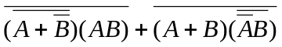

1.

2.
- Boolean Algebra

How many ordered triples make the following Boolean expression TRUE?

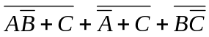

3.
- Graph Theory
Between which pair(s)
of vertices are there no paths of length 4 in the directed graph at the right?

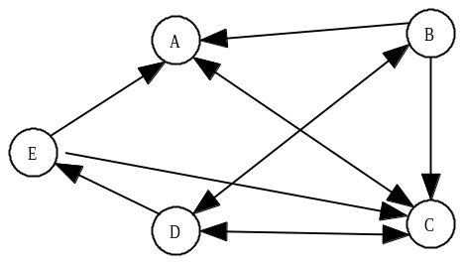

- Graph Theory
How many different cycles are there from C in the directed graph at the right?

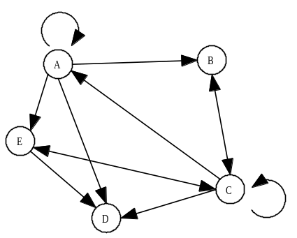

4.

- Bit-String Flicking
Solve the following for X (5-bit string) that satisfies the equation:

(LCIRC-2 01011) OR X = RSHIFT-1 11011

5.

